**Week 10**

**Assessment 1**

1. **UNF**

Laundry Receipt (SalesID, Date, Payment Type, Customer Name, Phone, Address, {No, ItemID, ItemName,Price,Weight, SubTotal}, Total,EmployeeName, Position)

* **1NF**

Laundry Receipt(**SalesID** , Payment Type, Customer Name, Phone, Address, EmployeeName, Position)

ReceiptDetail(**SalesID**, **Item ID** , ItemName, Price, Weight)

* **2NF**

Laundry Receipt(**SalesID** , Payment Type, Customer Name, Phone, Address, EmployeeName, Position)

ReceiptDetail(**SalesID**  , **Item ID,** weight)

LaundryDetail(**Item ID**, Item Name, Price)

* **3NF**

Customer(Customer Name, Phone, Address)

Customer Category(CUstomerID, CustomerName, Phone, Address, Category)

Position (**Position ID**, Position)

Employee(**Employee ID** , **Position ID** , EmployeeName, Employee Contact. Phone, Address)

Payment Type (**PaymentID** , Payment Type, PaymentName)

Laundry Receipt(**SalesID,**  Payment Type ID, Cashier Name)

Laundry Detail (**Item ID** , Category ID, Item Name, Price)

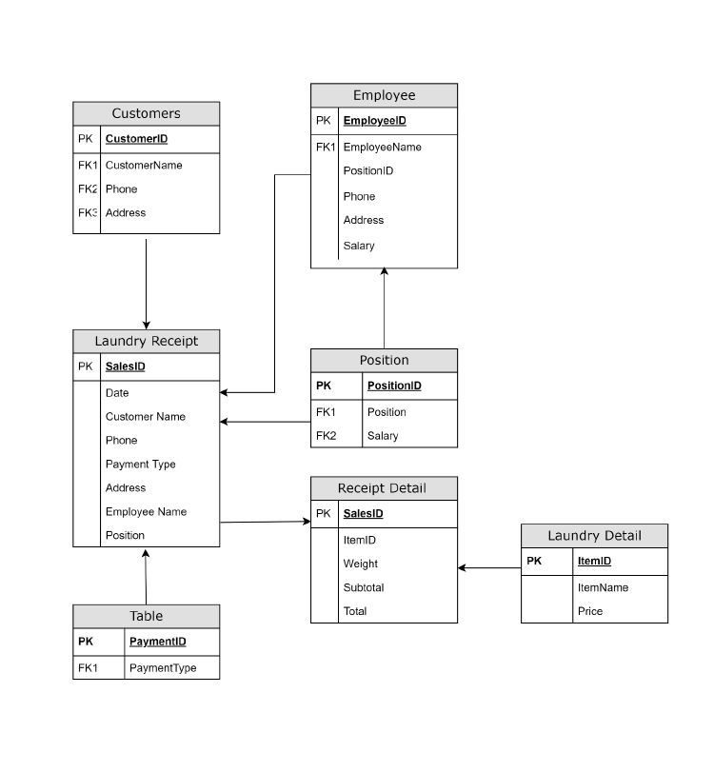

**Employee ABSENCE**

UNF

Employee Absence(AttendanceID, AttendanceDate, {EmployeeID, EmployeeName, AttendanceStatus, AttendanceTime}, TotalPresent, TotalAbsent, EmployeeName, Positions)

2. 1NF

• EmployeeAbsence(AttendanceID, AttendanceDate, ExecutiveID, ExecutivePosition)

• Absence Detail(AttendanceID, EmployeeID, EmployeeName, AttendanceStatus, AttendanceTime, Total Present, TotalAbsent)

3. 2NF

• EmployeeAbsence(AttendanceID, AttendanceDate, ExecutiveID, ExecutivePosition)

• Absence Detail(AttendanceID, EmployeeID, EmployeeName, AttendanceStatus, AttendanceTime, Total Present, TotalAbsent)

• Attendance(Attendance ID, AttendanceDate,AttendanceTime,Attendance Status)

4. 3NF

• Employee(EmployeeID, EmployeeName, PositionID, Phone, Address, Salary)

• Positions(Positions, PositionID,Salary)

• EmployeeAbsence(AttendanceID, AttendanceDate, ExecutiveID, ExecutivePosition)

• Absence Detail(AttendanceID, EmployeeID, EmployeeName, AttendanceStatus, AttendanceTime, Total Present, TotalAbsent)

• Attendance(Attendance ID, AttendanceDate,AttendanceTime,Attendance Status)

